Appendix 10: SWIFT Survey Child Safety Risk: Adolescents




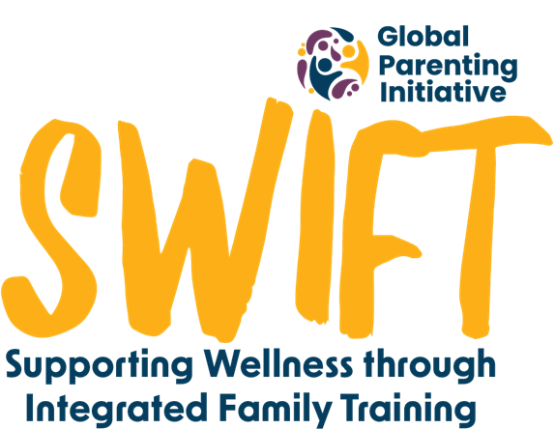


Briefing and telephonic assent:

Hi there _____, I’m _________. Your X(relationship/name) gave us your number and permission to speak to you but even though they have given permission, I want to make sure you are okay with speaking to me too. Is now a good time for us to talk? I have just 8 questions to ask you.
If it is not a good time - That’s okay. When would be a good time for me to call you back? Our conversation will take 15 minutes or less. (Arrange a time and day for a follow-up call).

Great. Thank you for making the time to speak to me. Before you decide if you want to talk to me, I want to tell you a little bit more about what I want to speak to you about so that you know what you are saying yes to. As I explain things, I will keep asking if you understand. Please let me know if I was being confusing or if I used a word or spoke about something you didn’t understand. Can I go ahead and explain?

This phone call will only take us about 15 minutes. After we finish, you will get a R15 social media data bundle to say thank you. We would like to ask you a few questions about your life and your relationship with your X. I’m working on a project that offers support to parents and caregivers through WhatsApp. We are looking at how it's working and how the children have found it. We want to hear what your experience of it was. There are no right or wrong answers here. Just be honest, we just want to hear what you think. Your family won’t know what you have answered. We will only share something with them if we are worried about your safety and we will first let you know and speak to you about it before we share it. Do you have any questions about this?

I want to share the answers you give, but when I share it, I will give you a different name. We want to keep your name and identity secret so we will use another name for you when we share anything. Would you like to choose the name we use for you?

If it's okay with you I will be recording this phone call, so I can remember your answers later. Only the people working with me on this project will hear what you say, but we won’t share your real name with anyone. Do I have permission to record?

Even if you have given me permission to talk to you, if you change your mind at any point or if you don’t want to answer something specific then you can just let me know.
Do you have any questions?
Can I have your permission to have this conversation with you?

If yes* - Thank you so much, can we begin?
If they say no - no problem at all, thanks for listening to me.
[* only begin only once participant has answered yes]
I am going to ask you a few questions. These are all multiple-choice questions. This means that when you answer, you will only choose which answer is best. The options are ‘Never’, ‘Sometimes’ or ‘Often’. All of the questions ask about how often in the last week something happened. You will then choose the best answer from ‘Never’, ‘Sometimes’ or ‘Often’. We only want you to answer about the last week or 7 days. Today is _____, so that means I’m asking how often something happened since last ____. Then you can answer ‘Never’ if it hasn’t happened at all since last ____, ‘Often’ if it happened almost every day, or about 5 times in the last week, and ‘Sometimes’ if it's somewhere between, such as 1 or 2 times. Does this make sense? (wait for reply)
If yes - Lets try an example. Since last ____, how often did you play games on a phone? (after they reply, check for understanding. Ie ‘So does that mean you did play games on your phone almost every day/didn’t play any games at all/only played games on 1 or 2 days’)
If no - what part is a bit confusing? Then I can explain it properly. Repeat until it is clear that they understand.
Okay, are you ready? I will go through each question slowly with you. Please let me know if you do not understand what I am asking, or if you have any questions while we are going.

- Since last _____, how often did you spend time with friends that your x (parent/caregiver) doesn’t know or doesn’t trust? Never, Sometimes, or Often.
  - Since last _____, did your x talk to you about spending time with friends that they don’t know or trust? Yes or No.

- Since last _____, how often did you go to a tavern, or drink alcohol with your friends? Never, Sometimes, or Often.
  - Since last _____, did your x talk to you about going to a tavern or drinking alcohol with friends? Yes or No.

- Since last _____, how often were you out of the house at night alone, or your x didn’t know where you were, or you came home later than your x expected? Never, Sometimes, or Often.
  - Since last _____, did your x talk to you about being out of the house at night alone, or somewhere where they didn’t know where you were, or about coming home later than your x expected? Yes or No.

- Since last _____, how often did you get a lift in a car with someone you don’t know? Never, Sometimes, or Often.
  - Since last _____, did your x talk to you about getting a lift in a car with someone you don’t know? Yes or No.

- Since last _____, how often did you receive sexual comments from men or women who are older than you? Never, Sometimes, or Often.
  - Since last _____, did your x talk to you about receiving sexual comments from men or women who are older than you? Yes or No.

- Since last _____, did your x talk to you about keeping safe from situations such as sexual violence? Yes or No.

- Since last _____, how often could you talk to your x about personal things like boyfriends, girlfriends, or sexual behaviour? Never, Sometimes, or Often.

Thank you. I just have two more questions for you about spending time online.

- Since last _____, how often did your x talk to you about using your cell phone or being on the internet? Never, Sometimes or Often.

- Since last _____, how often did your x know what you were doing when you were using the internet or using the cell phone? Never, Sometimes or Often.

Debriefing

I don’t have any more questions for you. Thank you so much for talking to me, is there anything else that you’d like to ask me, or that you want me to know?

How did you find answering the questions? Was there anything that made you feel scared or worried when answering my questions? We can talk about it.
If they say nothing concerns them - If after you are finished talking to me today you are feeling emotional or want to talk to someone about something that's worrying you, do you know about the Childline number that you can call for free? If you call 116, trained people answer those calls and know how to help children with any problem.

To say thank you for answering our questions, we would like to give you a data bundle. Can I send the voucher number to this cell phone number? What service provider are you with, e.g. MTN, Vodacom?

If you have any more questions for me after this phone call, please send us a WhatsApp. This is our number if you want to write it down or save it in your phone: insert study WhatsApp number.

Alright, we’ve come to the end of our conversation. Thanks again for taking the time to speak with us today. Your responses have been very helpful!

